**Logging using SLF4J**

**Exercise 1: Logging Error Messages and Warning Levels Task:**

**SCENARIO :**

Write a Java application that demonstrates logging error messages and warning levels using SLF4J.

Step-by-Step Solution:

1. Add SLF4J and Logback dependencies to your `pom.xml` file.

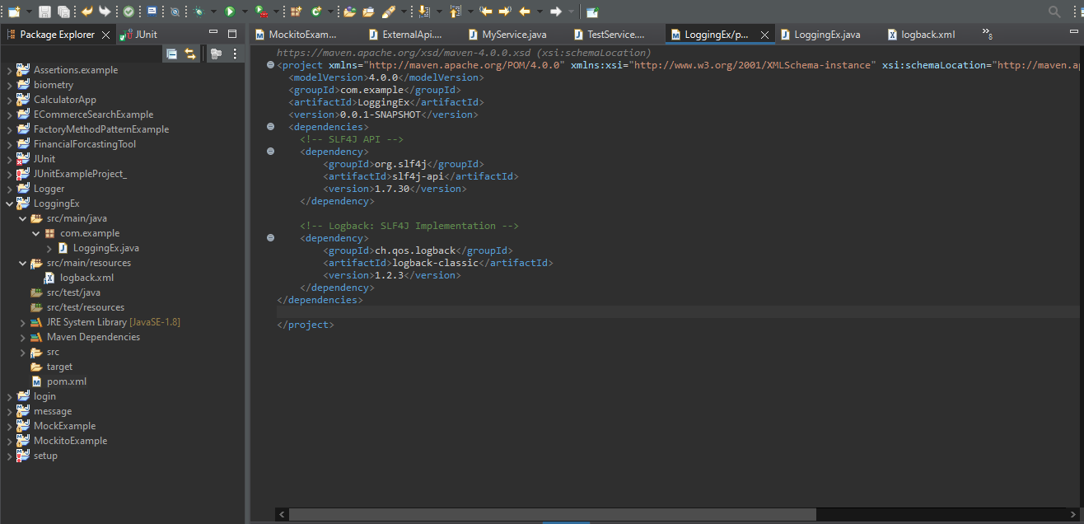

1. Create a Java class that uses SLF4J for logging.

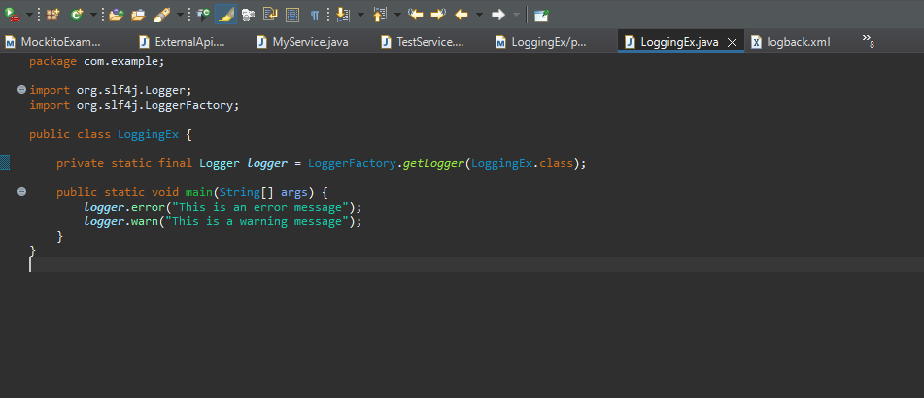

**OUTPUT:**

